POWER SAVER FOR INDUSTRIES & COMMERCIAL ESTABLISHMENTS
ABSTRACT
The project is designed to reduce the power loss in industries by power factor compensation through a number of shunt capacitors. This results in reduction in amount of electrical bill for industries and commercial establishments.
Power factor is defined as the ratio of real power to apparent power. This definition is often mathematically represented as KW/KVA, where the numerator is the active (real) power and the denominator is the (active + reactive) or apparent power. Reactive power is the non working power generated by the magnetic and inductive loads, to generate magnetic flux. The increase in reactive power increases the apparent power, so the power factor also decreases. Having low power factor, the industry needs more energy to meet its demand, so the efficiency decreases.
In this proposed system the time lag between the zero voltage pulse and zero current pulse duly generated by suitable operational amplifier circuits in comparator mode are fed to two interrupt pins of the microcontroller. Microcontroller displays the power loss due to the inductive load on the LCD. The program takes over to actuate appropriate number of relays at its output to bring shunt capacitors into the load circuit to get zero power loss. The 8 bit microcontroller used in the project belongs to PIC family.
Further the project can be enhanced by using thyristor control switches instead of relay control to avoid contact pitting often encountered by switching of capacitors due to high in rush current.

BLOCK DIAGRAM
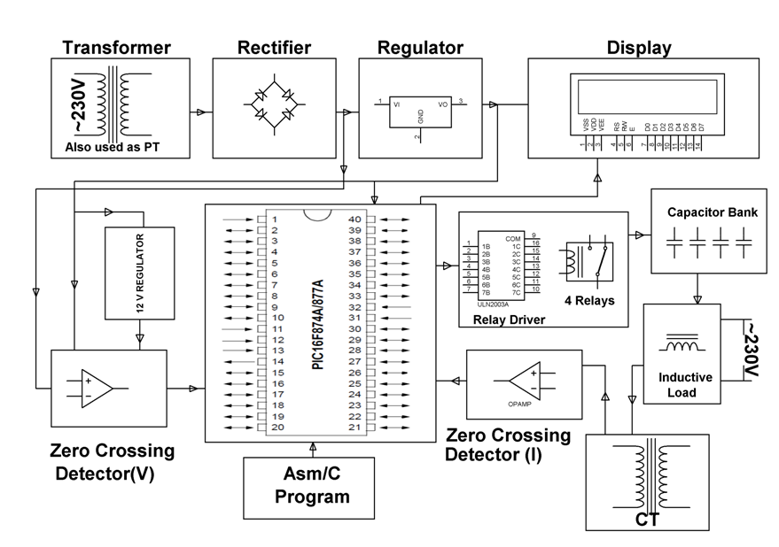

HARDWARE REQUIREMENTS:
PIC series Microcontroller, Op-amps, LCD, Shunt Capacitors, Relays, Relay driver IC, Current Transformer, Choke, Crystal, Toggle Switches, Resistors, Capacitors, Diodes, Transformer, Voltage Regulator, Lamp.
SOFTWARE REQUIREMENTS:
HI-TECH PICC Tool suite
Languages: Embedded C or Assembly

